The Aquinas Institute, Blackfriars, Oxford, Annual Colloquium
Saturday 4th March, 2017, 9.30am - 5.00pm
Aquinas and Newman
on Conscience
Freedom of Conscience is a right widely promoted, and widely withheld. If, as Elizabeth Anscombe remarked, “a man’s conscience may tell him to do the vilest things,” how absolute are its rights? Do we need to clarify what conscience is, and how it follows from our creation in God’s image, if we are to state its duties, privileges and limitations, and cherish it without idolising it? This forms one strand of a joint research project of the Aquinas and Las Casas Institutes: Human Nature & Dignity: Resources for the 21st Century. The 2017 Colloquium launches this strand of research. By contrasting Aquinas and Newman we will sharpen the question what conscience is; bringing out common elements in the two theologians will promote precision on its rights, and on its responsibilities which Church and State must foster. A paper contrasting Aquinas and Calvin will illustrate the range of accounts Newman inherited.

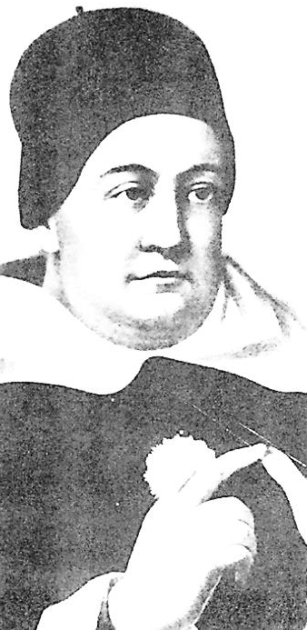
Main Speakers:
Candace Vogler (David B. & Clara E. Stern
Professor of Philosophy, Chicago)
Aquinas on Synderesis
Frederick Aquino (Professor of Theology,
Abilene Christian University)
Newman on Conscience
Aaron Taylor (DPhil student, Oxford)
Aquinas and Calvin on Conscience
A Disputation on Conscience will be held between someone representing Newman, and a fictitious 19th-Century Dominican

Fee for the day, including lunch: £10 (£5 students/unwaged)
The Colloquium is made possible by a generous donation from Prof. Barbara R. Walters-Doehrman and Steven R. Doehrman, in memory of, and with gratitude to, the late Eugene
Walters and the late Virginia and Ralph Doehrman, for which the Institute is very grateful.
Further information, & to register: Richard Conrad, O.P., Blackfriars, St. Giles’, Oxford, OX1 3LY
01865 278444 richard.conrad@bfriars.ox.ac.uk

