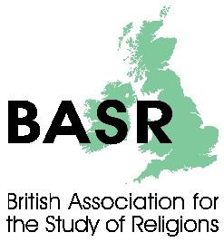
Call for papers
Annual Conference 2012

Borders, Boundaries and Transgressions:
within and between religions

University of Winchester, UK
5-7 September 2012

Keynote speakers are Prof Douglas Pratt, University of Waikato, New Zealand and Prof Douglas Davies, University of Durham, UK.

Scholars of religion and religions are invited to submit paper proposals related to the topic. The question of what religion is, whether there is such a thing, and, if so, what may constitute the borders and boundaries are matters of dispute. Papers exploring these topics, broadly conceived, including discussions of transgressions, whether within or between traditions or the conceptualization of the debates, are welcome.

Proposals in form of title, short abstract (300 words max.) and a brief biographical statement, including affiliation should be sent, by Friday 1st June 2012, to:
Dr Paul Hedges, BASR Conference, Theology & Religious Studies, University of Winchester,
SO22 4NR, UK or paul.hedges@winchester.ac.uk

Details of costs, accommodation, bursaries for postgraduate students, etc. will be available shortly on the BASR website http://www.basr.ac.uk

